**CAOL LAB 4**

**Name: Adnan Hatim**

**Student_ID: 24K0656**

TASK 1:

Code:

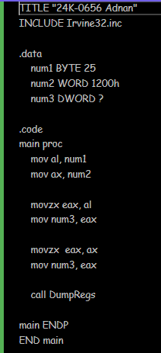

Output:

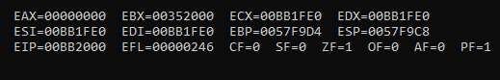

TASK 2:

Code:

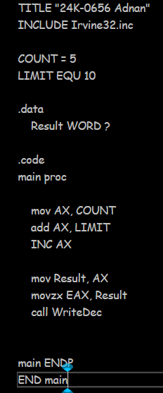

Output:

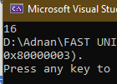

TASK 3:

Code:

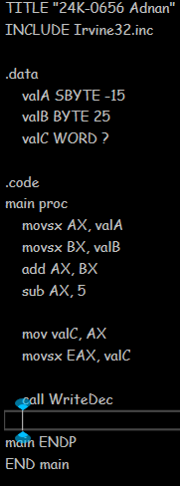

Output:

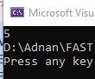

TASK 4:

Code:

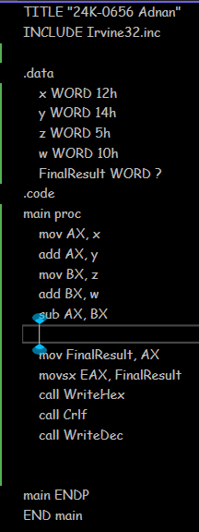

Output:

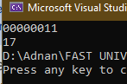

TASK 5:

Code:

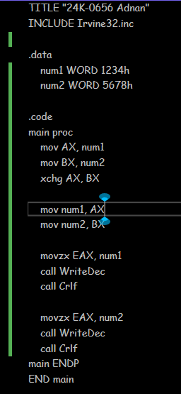

Output:

